Your Equalis price is 127.50 for a case of 24 8 oz gel. Sold by the case only. Pallet quantity discounts are available

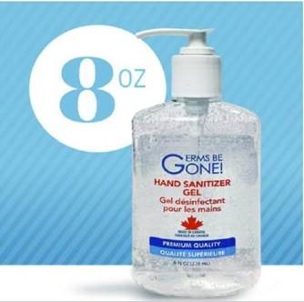

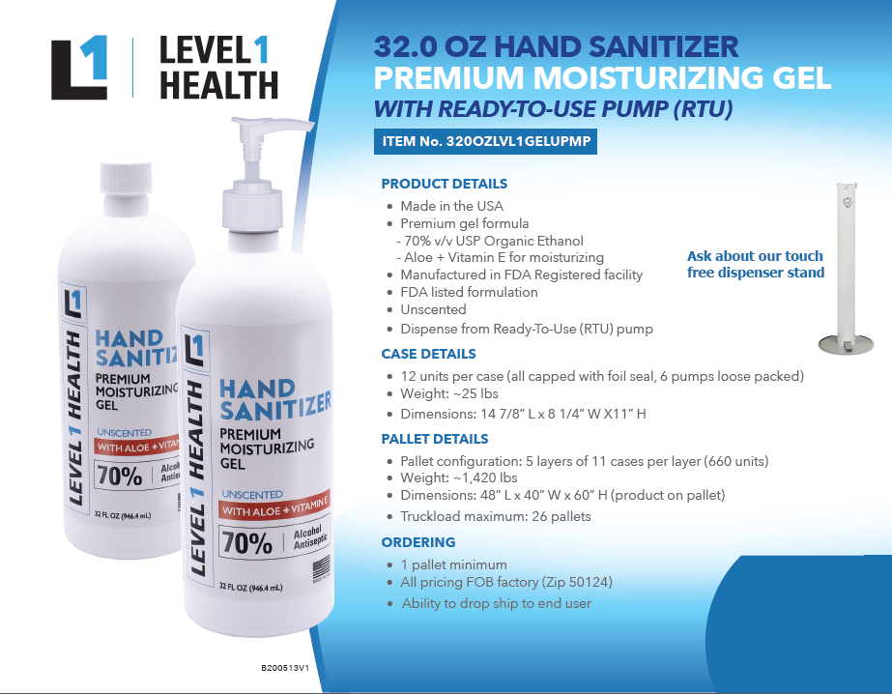

**Don Whiting**  
***Regional Manager***  
**Mellocraft Company**  
-----------------------------------

**3151 Hill Ave**

**Toledo Ohio 43607**

Telephone: (419) 867-7722

Fax: (419) 867-3377

Cell: (419) 481-1451

Web: mellocraft.com [dwhiting@mellocraft.com](mailto:%0bdwhiting@mellocraft.com)

