Equalis Group
Marketing
& Customer
Engagement Kit

Marketing & Customer Engagement Kit Overview
Thank you for your partnership with Equalis Group and your commitment to serving our members. Equalis is the only Supplier-Centric public sector cooperative in the country. We see and value you, our supplier partners, as our customers. Our job is to make it easy for you to Attract, Retain, and Grow public sector business.

Lately, our supplier partner community has asked us more and more for a range of specific resources. Everything from content that supplier partners can use for a dedicated Equalis landing page on their site to messaging that can be incorporated into ongoing supplier partner marketing campaigns to answers to questions commonly asked by either sales reps or customers.

We developed this Marketing & Customer Engagement Kit as a one-stop-shop to respond to these requests and as part of our commitment to you and your success. It is a compilation of content, messaging, and sales tools Equalis packaged as easy-to-deploy templates for use by our entire supplier partner community. Each of these resources has been utilized successfully in the marketplace by Equalis and/or our supplier partners.

This kit contains resources for your marketing team, sales leadership, and sales reps, including:
- Approved Equalis-related content for your website
- An approved, customizable press release template and social media post to announce/promote our Master Agreement
- Five email templates to utilize in marketing campaigns and/or the sales process with current, former, and prospective customers
- Answers to questions commonly asked by sales reps (including when and how to introduce Equalis to a customer) and by customers

The following page contains a hyperlinked table of contents so you can quickly navigate to the resources most relevant to you at any point in time.

Each customizable content resource (items 1 through 9) includes an introductory Context & Application section, which includes (in Italics) the purpose and description of the content, along with guidance on how to customize and utilize the content we have provided. The content (in normal text) follows, typically on the next page. NOTE: all text highlighted in yellow or blue needs to be customized before you deploy the content. The content is approved by Equalis for your use as written; please send us any changes you make to non-highlighted content for our review prior to publication and/or distribution.

Click here to access Equalis logos and our style guide.

The email templates (items 5 through 9) can be used by your sales team as stand-alone email communications to customers and/or by your marketing team as additions to current and/or future marketing campaigns. These templates include language that can be excerpted and utilized on your website and/or in marketing collateral.

The answers to common sales rep and customer questions (items 10 through 12) are intended for utilization by your sales team, whether in routine trainings and/or as resources for your sales reps during the sales process.

Thank you to all of our supplier partners who have been involved in creating and utilizing these resources. They have proven to be effective in generating awareness of our Master Agreements and in Attracting, Retaining, and Growing public sector business. We are confident this Marketing & Customer Engagement Kit will prove to be valuable for your company as well.

Questions? Comments? Smart remarks? Shoot us a note at Engagement@EqualisGroup.org.

Table of Contents
1. Dedicated Equalis Group Landing Page Content 1
2. Your Existing Cooperative Landing Page Content 3
3. Press Release Template 4
4. Contract Award LinkedIn Post 6
5. Email Template: Re-Engaging Former Customers 7
6. Email Template: Expand your Relationship with Current Customers 9
7. Email Template: Renewing Current Customer Agreements 11
8. Email Template: Targeting Prospective Customers 13
9. Email Template: Responding to a Lost Bid/RFP 15
10. For Sales Reps: When to Introduce Equalis Group to a Customer 17
11. For Sales Reps: Questions Asked Frequently by Reps 18
12. For Sales Reps: Questions Asked Frequently by Customers 19

1. Dedicated Equalis Group Landing Page Content
Context & Application
Purpose: to promote your Master Agreement with Equalis Group via a dedicated landing page on your website. Creating a dedicated Equalis landing page that promotes our Master Agreement will increase organic web traffic to your site and inform visitors that you were awarded a publicly procured, competitively solicited contract through which they can purchase your products and services without having to conduct a formal bid or request for proposals (RFP).

Description: this content addresses who Equalis is, how your Master Agreement was procured, and why customers/prospects should join Equalis to purchase your products and services through a legal exemption to the traditional bid/RFP process.

Utilization: tailor this content to your company and industry by updating the highlighted text. This content is approved by Equalis for your use without any further authorization from Equalis. You may use this content in its entirety or utilize any individual section(s). Supplement this Equalis content with any additional information you want to include regarding your company, products and services available, and/or key Master Agreement terms you determine are relevant to your customers and prospects.

Actions:
- Complete the Master Agreement Procurement Process section by going to your Equalis landing page to determine which Lead Agency issued the RFP (top right) and the name of the RFP (open the Original RFP link on the bottom right).
- Send any proposed edits of non-highlighted text to Equalis Marketing & Engagement for review and approval prior to publication on your site.
- Include one of the Equalis logos in accordance with our Graphic Style Guide, both found here.
- Send the link to your dedicated Equalis landing page to Equalis Marketing & Engagement; we will cross-link to it from your landing page on the Equalis website.

About Equalis Group
Equalis Group is a national cooperative purchasing organization that provides contracts competitively solicited by public agencies (Lead Agencies) for a wide array of products and services. Equalis Master Agreements are established through competitive solicitations conducted in accordance with public procurement guidelines ensuring members stay in compliance.

Equalis works hand-in-hand with its members and Lead Agencies to develop and deliver industry-leading solutions from highly qualified and experienced suppliers, including Supplier Name. Public sector entities, including federal and state agencies, local governments, and educational institutions across the country can utilize Equalis cooperative agreements to:
- Quickly acquire the products and services they need;
- Receive better pricing through the collective buying power of Equalis Members;
- Leverage the expertise of awarded suppliers to develop the best solutions; and,
- Save time through Equalis’ legal and compliant exemption to conducting their own resource-consuming solicitation process.

Equalis is a Member-Driven organization that believes in the power of partnership: when working together, we achieve more.

Master Agreement Procurement Process
Region 10 Education Service Center (Region 10) / The Cooperative Council of Governments (CCOG), an Equalis lead agency, conducted a rigorous and transparent competitive public sector procurement process for Name of RFP. Region 10 / CCOG evaluated each response on both qualitative and cost criteria and awarded a contract to Supplier Name as the responsible offeror whose proposal is most advantageous.

This contract was procured and awarded in accordance with the requirements of 2-C.F.R. Part 200, commonly referred to as “Uniform Guidance”, so you can spend federal grant and award dollars through this contract vehicle without having to conduct your own bid or request for proposals (RFP) for our products and services.

Join Equalis Group
Public sector entities nationwide that join Equalis have immediate access to Supplier Name’s competitively solicited contract vehicle, as well as the entire Equalis portfolio of cooperative contracts. Each contract provides members with a legal and compliant exemption to the traditional bid/RFP process and the ability to configure the solution that best meets their individual needs while achieving the lowest total cost.
- Save Time – Equalis’ publicly procured, competitively solicited contracts save public sector entities time by providing them with a legal exemption from conducting their own bid or RFP process.
- Save Money – Equalis’ sourcing expertise combined with the collective buying power of Equalis members ensure that members save money when purchasing through Equalis Master Agreements.
- Stay Legal – Compliance is key. Equalis Lead Agencies’ rigorous procurement processes comply with statutory requirements and adhere to 2-C.F.R. Part 200 (Uniform Guidance), ensuring Equalis members can purchase through an entire portfolio of Master Agreements using federal funds with confidence and peace of mind.

Not a member yet? Any public sector entity in the country can join Equalis and begin utilizing any Equalis competitively solicited Master Agreement by completing the membership registration form. New members receive a fully executed copy of their completed membership form via email immediately and will quickly receive their Equalis membership number and welcome kit. There are no membership dues, fees, or obligations and completing the form takes less than five minutes.

Each Equalis member is assigned a dedicated point of contact to provide ongoing support, with a name, direct dial, and email address. This individual works tirelessly to help members manage the complexities of designing and implementing the best solutions through publicly procured Equalis agreements.

2. Your Existing Cooperative Landing Page Content
Context & Application
Purpose: to promote your Master Agreement with Equalis Group via your existing landing page on your website that showcases each of your cooperative agreements/public sector contract vehicles. This option is for supplier partners who cannot or choose not to create a dedicated Equalis landing page. Of course, our preference is that you build a dedicated Equalis landing page to increase organic web traffic to your site and inform visitors that you were awarded a publicly procured, competitively solicited contract through which they can purchase your products and services without having to conduct a formal bid or request for proposals (RFP).

Description: this content provides a brief overview of Equalis, addresses who Equalis is, and summarizes why customers/prospects should join Equalis to purchase your products and services through a legal exemption to the traditional bid/RFP process.

Utilization: this content is approved by Equalis for your use without any further authorization from Equalis. Supplement this Equalis content with any additional information you want to include regarding your company, products and services available, and/or key Master Agreement terms you determine are relevant to your customers and prospects.

Actions:
- Send any proposed edits of non-highlighted text to Equalis Marketing & Engagement for review and approval prior to publication on your site.
- Include one of the Equalis logos in accordance with our Graphic Style Guide, both found here.
- Send the link to your cooperative/contract vehicle landing page to Equalis Marketing & Engagement.

Equalis Group
Equalis Group is a national public sector purchasing cooperative that develops and administers a diverse portfolio of cooperative purchasing programs that cover a wide range of products and services. Each program in Equalis’ rapidly growing portfolio provides its members with a legal and compliant exemption to the traditional bid/request for proposals (RFP) process and the ability to configure the solution that best meets their individual needs while achieving the lowest total cost.

This contract was procured and awarded in accordance with the requirements of 2-C.F.R. Part 200, commonly referred to as “Uniform Guidance”, so public agencies can spend federal grant and award dollars through this contract vehicle without having to conduct their own bid or RFP for our products and services.

Not a member yet? Any public sector entity in the country, including federal and state agencies, local governments, and educational institutions, can join Equalis and begin utilizing any Equalis competitively solicited Master Agreement by completing the membership registration form. New members receive a fully executed copy of their completed membership form via email immediately and will quickly receive their Equalis membership number and welcome kit. There are no membership dues, fees, or obligations and completing the form takes less than five minutes.

3. Press Release Template
Context & Application
Purpose: to generate awareness of your newly established Equalis Group Master Agreement, drive inbound sales opportunities, and produce organic web traffic.

Description: this template includes information public sector entities want to know about cooperative contract awards, such as the name of the request for proposal (RFP), the Lead Agency that issued the RFP, information about key contract terms, the range of products and services available through the Master Agreement, and information about your company and Equalis Group.

Utilization: tailor this content to your company and contract award by updating the highlighted text.

Actions:
- Complete the first paragraph and Contract Information section by going to your Equalis landing page to determine the name of the RFP (open the Original RFP link on the bottom right), which Lead Agency issued the RFP (top right), and contract information (top right). Add the hyperlink to your Equalis landing page where the words “landing page” are highlighted in blue below.
- Insert a description of your products and services available through the Master Agreement in the second paragraph.
- If desired, insert a quote from a leader in your organization in the third paragraph.
- If desired, draft a quote from an Equalis leader in the sixth paragraph. We will review/edit the quote and provide a name and title for attribution.
- Insert a description of your company in the About Supplier Name section.
- Send an initial draft of the press release to Equalis Marketing & Engagement for review and approval prior to publication.

Supplier City, State – Supplier Name is pleased to announce that it has earned a publicly procured, competitively solicited contract award for RFP Name from Region 10 Education Service Center (Region 10) / The Cooperative Council of Governments (CCOG), an Equalis Group Lead Agency.

Describe products and services available through the contract and any other contract features and benefits

Supplier Name Quote

Equalis Group delivers compliant, publicly procured cooperative agreements that public sector entities, including federal and state agencies, local governments, and educational institutions across the country can utilize to: i) quickly acquire the products and services they need; ii) receive better pricing through the collective buying power of Equalis Group Members; and, iii) save time through Equalis Group’s legal and compliant alternative to conducting their own resource-consuming solicitation process.

This contract was procured and awarded in accordance with the requirements of 2-C.F.R. Part 200, commonly referred to as “Uniform Guidance”. Why is that important? Because public sector entities receiving federal grant and award dollars can typically spend those dollars through Equalis Group’s already-procured contracts without having to conduct their own bid or request for proposals (RFP).

Equalis Group Quote

How to Purchase through this Contract:
This cooperative contract vehicle is immediately available to Equalis Group members. Any public sector entity within the United States can join Equalis Group and begin utilizing this competitively solicited contract by completing the membership agreement, located here. There are no dues, fees, or obligations to join Equalis Group.

Contract Information:
Contract #: contract number
Effective Date: effective date
Expiration Date: expiration date
Renewable Through: renewable through date

Additional information regarding the procurement process and contract award can be found on the Supplier Name landing page on the Equalis Group website.

About Supplier Name:
Supplier Name Description

About Equalis Group:
Equalis Group is a national public sector purchasing cooperative that develops and administers a diverse portfolio of cooperative purchasing programs that cover a wide range of products and services. Each program in Equalis’ rapidly growing portfolio provides its members with a legal and compliant exemption to the traditional bid/RFP process and the ability to configure the solution that best meets their individual needs while achieving the lowest total cost.

4. Contract Award LinkedIn Post
Context & Application
Purpose: to promote your newly awarded Equalis Group Master Agreement on LinkedIn.

Description: this post notifies your followers that your company earned a contract award from an Equalis Group Lead Agency, describes the range of products and services available through the Master Agreement, and links to your landing page on the Equalis website.

Utilization: tailor this content to your company and contract award by updating the highlighted text.

Actions:
- Go to your Equalis landing page to determine the name of the RFP (open the Original RFP link on the bottom right) and which Lead Agency issued the RFP (top right).
- Insert a brief description of your products and services available through the Master Agreement.
- Add the hyperlink to your Equalis landing page where the words “landing page” are highlighted in blue below.
- Tag our company LinkedIn page at the first mention of Equalis Group: @Equalis Group.
- Incorporate hash tags that work for your company and for Equalis. Please use the following tags, which typically generate engagement for our LinkedIn posts:
  - #procurement
  - #publicsector
  - #cooperativepurchasing
  - #cooperatives

Supplier Name is pleased to share that it has earned a publicly procured, competitively solicited contract award for RFP Name from Region 10 Education Service Center (Region 10) / The Cooperative Council of Governments (CCOG), an Equalis Group Lead Agency. This agreement will allow Supplier Name to provide products and services to public sector entities, including federal and state agencies, local governments, and educational institutions across the country through a legal and compliant exemption to the traditional bid/request for proposals process. This contract was procured and awarded in accordance with the requirements of 2-C.F.R. Part 200, commonly referred to as “Uniform Guidance”. To learn more about this new and exciting contract vehicle, visit our Equalis Group landing page.

5. Email Template: Re-Engaging Former Customers
Context & Application
Purpose: to promote your Equalis Group Master Agreement to former customers.

Context: do you have former customers who are not current customers? Maybe your company delivers project work – you have delivered projects with these prior customers in the past through winning bids or another contract vehicle that is no longer available, they’d like to be able to work with you again, and they need a way to be able to buy from you.

Or maybe you had a longstanding business relationship that you lost to a competitor because of the vagaries of the public procurement process, or a competitor undercut your pricing in the most recent bid. The former customer would love to re-establish a relationship with you, and they need a way to do it legally.

We have worked with numerous supplier partners to help them win back former customers using the email template below.

Description: this email template is designed to be sent by an individual sales representative to a prior customer. It can easily be modified to be sent from a corporate email address by whomever sends emails to customers and prospects from your company as part of a larger campaign.

The proposed Subject Header uses a highly effective military style in which the requested action is presented in ALL CAPS. We have had tremendous success in generating responses using this exact subject header. The subject header may seem long to you, but it most certainly works. Additionally, the email closes with a specific call to action that corresponds to the subject header.

The tone of the email is conversational and empathetic. It reflects your former customers’ desire to purchase your products and services through a piggybackable contract vehicle and to be able to spend federal funds with you without having to conduct their own bid or request for proposals.

We use “Thank you,” as the closing because “Thank you” is statistically shown to be the most effective close to an email, as opposed to “Best regards”, “Warmly”, or “Thanks”. Also, it is far more effective than having no closing and relying on just an email signature.

Utilization: tailor this content to your company and contract award by updating the highlighted text.

Actions:
- Determine from whom and to whom the emails will be sent.
- Customize the template accordingly.
- Propose a specific time and date to schedule a conversation.
- Hit send.

Subject Header:
REQUEST FOR CALL: Supplier Name’s federal funds-eligible, competitively solicited Equalis Group contract vehicle

Email Content:
Contact Name,

Thank you for being a Supplier Name customer in years past. We are grateful for the trust you placed in us to meet your products and services needs.

So many of our public sector customers have asked us if we have a piggybackable and federal funds-eligible contract vehicle they can use to contract with us directly without having to conduct their own bid or request for proposals (RFP) process. Our customers value Supplier Name’s dependability, consistency, and quality, and many of you have told us you would award new business to us directly if you could.

Public sector customers routinely express their frustration with the delays resulting from the bid/RFP process. They tell us about the limitations of the RFP process, and how they are often forced to award contracts to “less expensive” second- and third-tier vendors that wind up costing so much more in the end.

I am pleased to share with you that we listened, aggressively pursued a solution, and won a competitively solicited, publicly procured contract award from an Equalis Group Lead Agency. Equalis is a nationwide public sector cooperative purchasing organization.

What does this contract award mean for you? You can now choose to work with Supplier Name again for your critical products and services needs without the limitations and frustrations of a traditional procurement process. This contract was procured and awarded in accordance with the requirements of 2-C.F.R. Part 200, commonly referred to as “Uniform Guidance”, so you can spend federal grant and award dollars through this contract vehicle without having to conduct your own bid or RFP for our products and services.

Let’s talk about how Supplier Name’s relationship with Equalis gives you the power to reengage Supplier Name. Are you available at time on date for a quick call?

Thank you,
Your Name

6. Email Template: Expand your Relationship with Current Customers
Context & Application
Purpose: to promote your Equalis Group Master Agreement to current customers to expand the scope of products and services you sell to them without having to go through the bid or request for proposals (RFP) process.

Context: do you have existing customers who only buy a portion of the products and services your company offers? Maybe they issued a bid that you won for a specific product, one of hundreds or thousands that you offer. Or they issued a bid for a category of products and services you offer, but only a portion of the breadth of your capabilities.

You have built a great relationship with the customer. They like and trust you. They would be open to learning about other products and services you offer, or maybe have even told you that they are going out to bid at some point for those products and services and want to make sure you respond to the bid.

With a private sector customer, you can easily leverage the relationship you’ve built to expand the scope of products and services you are selling to that customer. In the public sector, the customer needs to run their own bid, which you might lose to a competitor, or utilize some type of contract vehicle to be able to buy these additional products and services from you.

We have worked with numerous supplier partners to help them expand their sales to current customers using the email template below.

Description: this email template is designed to be sent by an individual sales representative to a current customer. It can easily be modified to be sent from a corporate email address by whomever sends emails to customers from your company as part of a larger campaign.

The proposed Subject Header uses a highly effective military style in which the requested action is presented in ALL CAPS. We have had tremendous success in generating responses using this exact subject header. The subject header may seem long to you, but it most certainly works. Additionally, the email closes with a specific call to action that corresponds to the subject header.

The tone of the email is conversational and empathetic. It reflects your current customers’ desire to purchase more of your products and services through a piggybackable contract vehicle and to be able to spend federal funds with you without having to conduct their own bid or RFP.

We use “Thank you,” as the closing because “Thank you” is statistically shown to be the most effective close to an email, as opposed to “Best regards”, “Warmly”, or “Thanks”. Also, it is far more effective than having no closing and relying on just an email signature.

Utilization: tailor this content to your company and contract award by updating the highlighted text.

Actions:
- Determine from whom and to whom the emails will be sent.
- Identify the products and services the customer is buying and those which they can begin to purchase from you.
- Customize the template accordingly.
- Propose a specific time and date to schedule a conversation.
- Hit send.

Subject Header:
REQUEST FOR CALL: Supplier Name’s federal funds-eligible, competitively solicited Equalis Group contract vehicle

Email Content:
Contact Name,

Thank you for being a Supplier Name customer. We are grateful for the trust you place in us to meet your products and services needs.

You may not be aware that in addition to products and services you currently sell to the customer, we also provide products and services the customer is not currently purchasing from you as well.

It is common for us to begin working with a first-time customer by providing a small portion of our entire breadth of products and services. As you know from your own experience with us, we deliver, we perform, and we earn our customers’ trust.

Once they get to know us, so many of our current public sector customers have asked us if we have a piggybackable and federal funds-eligible contract vehicle they can use to purchase additional products and services from us directly without having to conduct their own bid or request for proposals (RFP) process. Our customers value Supplier Name’s dependability, consistency, and quality, and many of you have told us you would award additional business to us directly if you could.

Public sector customers routinely express their frustration with the delays resulting from the bid/RFP process. They tell us about the limitations of the RFP process, and how they are often forced to award contracts to “less expensive” second- and third-tier vendors that wind up costing so much more in the end,
rather than being able to award the business to a company they know from personal experience they can rely on.

I am pleased to share with you that we listened, aggressively pursued a solution, and won a competitively solicited, publicly procured contract award from an Equalis Group Lead Agency. Equalis is a nationwide public sector cooperative purchasing organization.

What does this contract award mean for you? You can now purchase any of Supplier Name’s products and services for your critical products and services needs without the limitations and frustrations of a traditional procurement process. This contract was procured and awarded in accordance with the requirements of 2-C.F.R. Part 200, commonly referred to as “Uniform Guidance”, so you can spend federal grant and award dollars through this contract vehicle without having to conduct your own bid or RFP for our products and services.

Let’s talk about how our Equalis contract award gives you the power to expand your relationship with Supplier Name. Are you available at time on date for a quick call?

Thank you,
Your Name

7. Email Template: Renewing Current Customer Agreements
Context & Application
Purpose: to renew expiring contracts with current customers without having to go through the bid or request for proposals (RFP) process in order to retain the business.

Context: do you have contractual relationships with existing customers that will be expiring soon? There are no more renewal options to exercise, you have built a strong relationship, and both the customer and you want to continue to do business together uninterrupted.

However, because there are no more renewal options, both you and the customer are facing the prospect of another bid or RFP, which puts you both at risk of losing the relationship.

You will have to invest time and energy in responding to the new solicitation. Your relationship is with the end buyer, not with the procurement team that will be evaluating all the responses submitted, so your hard-earned relational equity has little to no value in the scoring process. You have competitors who want to take your business and may lowball their pricing or misrepresent their capabilities to win. Net net: the risk to you of losing the business is high.

From your customer’s perspective, they will also have to invest time and energy in the solicitation process, which is frustrating because they already know they want to maintain their existing relationship with you. And the award decision will be in the hands of the procurement team, not your end buyer who knows and trusts you and does not want to replace you with an unknown and/or lower quality competitor. Net net: the risk to your end buyer of losing your relationship is high.

We have worked with numerous supplier partners to help them retain their relationships with current customers using the email template below.

Description: this email template is designed to be sent by an individual sales representative to a current customer. It can easily be modified to be sent from a corporate email address by whomever sends retention messaging to customers from your company as part of a larger campaign.

The proposed Subject Header uses a highly effective military style in which the requested action is presented in ALL CAPS. We have had tremendous success in generating responses using this exact subject header. The subject header may seem long to you, but it most certainly works. Additionally, the email closes with a specific call to action that corresponds to the subject header.

The tone of the email is conversational and empathetic. It reflects your current customers’ desire to continue their existing relationship with you without having to conduct a bid or RFP.

We use “Thank you,” as the closing because “Thank you” is statistically shown to be the most effective close to an email, as opposed to “Best regards”, “Warmly”, or “Thanks”. Also, it is far more effective than having no closing and relying on just an email signature.

Utilization: tailor this content to your company and contract award by updating the highlighted text.

Actions:
- Think about the timing to send this email. Send it at least a month or two before the customer’s procurement team would make the decision to begin a new bid or RFP process. Once the decision is made to conduct a new solicitation, it may very well be too late.
- Customize the template accordingly. In the first paragraph, add color regarding your relationship to remind the customer of the value that you have provided during the term of your current contract.
- Propose a specific time and date to schedule a conversation.
- Hit send.

Subject Header:
REQUEST FOR CALL: I have a solution to our expiring contract

Email Content:
Contact Name,

We’ve been working together for number years now. Add color/history/background/successes.

Our current contract is expiring on date. We are out of renewal options, and both of us want to continue the relationship uninterrupted.

I have good news. Supplier Name won a competitively solicited, publicly procured contract award from an Equalis Group Lead Agency. Equalis is a nationwide public sector cooperative purchasing organization.

What does this contract award mean for us? We can establish a new contract to continue providing products and services to you without having to go through a new solicitation process.

You and I both know from experience the frustration associated with the time, effort, and expense that is required to run an RFP. The RFP process has numerous limitations, and potentially forces you to award contracts to second- and third-tier vendors because they are “less expensive,” rather than being able to award the business to us, a company you know from personal experience you can rely on.

In addition, this contract was procured and awarded in accordance with the requirements of 2-C.F.R. Part 200, commonly referred to as “Uniform Guidance”, so you can spend federal grant and award dollars through this contract vehicle.

Let’s talk about how Supplier Name’s relationship with Equalis gives us the ability to establish a new agreement. Are you available at time on date for a quick call?

Thank you,
Your Name

8. Email Template: Targeting Prospective Customers
Context & Application
Purpose: to i) make the prospect aware of your Equalis Group Master Agreement and the benefits it offers as a legal exemption to the bid or request for proposals (RFP) process as part of an existing/planned prospect outreach campaign, and ii) schedule a call or meeting.

Context: your company is seeking to grow public sector sales. You have identified prospective customers and either have already initiated direct outreach/a marketing campaign or intend to do so.

Your existing messaging is designed to promote your company and your capabilities. The content below is designed to be incorporated into your existing/planned outreach to public sector prospects to inform them that there is an easy way for them to begin purchasing your products and services without having to conduct a bid or RFP.

The critical point is that your company’s capabilities combined with your Equalis Group Master Agreement present the prospect with both the solution they need AND a way to purchase it immediately.

Description: this email template is designed to be sent by an individual sales representative to a prospective customer or incorporated into an existing/planned email campaign distributed to a public sector prospect list.

The proposed Subject Header uses a highly effective military style in which the requested action is presented in ALL CAPS. We have had tremendous success in generating responses using this exact subject header. The subject header may seem long to you, but it most certainly works. Additionally, the email closes with a specific call to action that corresponds to the subject header.

The tone of the email is conversational, empathetic, and informative.

We use “Thank you,” as the closing because “Thank you” is statistically shown to be the most effective close to an email, as opposed to “Best regards”, “Warmly”, or “Thanks”. Also, it is far more effective than having no closing and relying on just an email signature.

Utilization: tailor this content to your company and products and services by updating the highlighted text. Other potential applications of this content include:
- A sales rep sending a version of this email (modified to the specific situation) to a prospect in advance of/following one in a series of cold calls
- A sales rep incorporating the language regarding the ease of buying your company’s products and services through the Equalis Group Master Agreement into conversations with or voicemails left for prospective customers, whether as part of initial outreach or the ongoing selling process – see the text highlighted in green below for a sample voicemail message
- A sales rep sending this email to a customer point of contact with whom the rep is already engaged (e.g., the IT Director or Facilities Manager) to forward to the customer’s procurement team as part of the ongoing selling process

Actions:
- Customize the template accordingly.
- Propose a specific time and date to schedule a conversation.
- Hit send.

Subject Header:
REQUEST FOR CALL: Supplier Name’s federal funds-eligible, competitively solicited Equalis Group contract vehicle

Email Content:
Contact Name,

Do you have an immediate need for Products & Services and don’t have time to wait for your procurement team to conduct a formal bid or request for proposals (RFP) process? Has your procurement team ever awarded a contract for Products & Services to a supplier you knew was unqualified or ineffective and you’ve been stuck dealing with the resulting mess? Have you been tasked with finding a Products & Services solution, but don’t really know where or how to start?

Public sector customers routinely express their frustration with the delays resulting from the bid/RFP process. They tell us about the limitations of the RFP process, and how they are often forced to award contracts to “less expensive” second- and third-tier vendors that wind up costing so much more in the end. They describe how the formal procurement process prevents them from engaging with potential suppliers to fully understand the options that are available to them and leverage that expertise to develop the best Products & Services solution for their organization.

I am pleased to share with you that we listened, aggressively pursued a solution, and Supplier Name won a competitively solicited, publicly procured contract award with nationwide coverage from an Equalis Group Lead Agency. Equalis is a national public sector cooperative purchasing organization.

In addition, this contract was procured and awarded in accordance with the requirements of 2-C.F.R. Part 200, commonly referred to as “Uniform Guidance”, so you can spend federal grant and award dollars through this contract vehicle.

What does this contract award mean for you? You can now work with Supplier Name directly for your critical Products & Services needs without the limitations and frustrations of a traditional procurement process.

Are you available at time on date for a quick call?

Thank you,
Your Name

9. Email Template: Responding to a Lost Bid/RFP
Context & Application
Purpose: to create an opportunity to sell your products and services to a customer who awarded the contract to one of your competitors.

Context: a public sector entity issued a bid/request for proposals (RFP), your company responded, and the customer awarded the contract to one of your competitors.

Based on your knowledge and experience with the competitor and/or what you know about your end buyer, you reasonably anticipate that the customer will not be satisfied by your competitor for any number of reasons, such as not being able to fulfill their contractual obligations, meeting the customer’s expectations, and/or providing the level of service required.

In addition, it is distinctly possible that your end buyer is unhappy with Procurement’s contract award to your competitor and would prefer to do business with your company instead.

This email is designed to keep the relationship door open and create the opportunity to do business with the customer in the near term, rather than having to wait until the next bid/RFP cycle to have an opportunity to win the customer’s business.

Description: this email template is written to be sent by the individual on your team who owns that customer account (e.g., the sales rep) to two individuals: 1) the customer end buyer (e.g., the IT Director or Facilities Manager), and 2) the customer’s bid/RFP point of contact (e.g., the procurement person listed on the bid/RFP documents).

The tone of the email is conversational, empathetic, and informative.

We use “Thank you,” as the closing because “Thank you” is statistically shown to be the most effective close to an email, as opposed to “Best regards”, “Warmly”, or “Thanks”. Also, it is far more effective than having no closing and relying on just an email signature.

Utilization: tailor this content to your company and the bid/RFP by updating the highlighted text.

Actions:
- Customize the template accordingly.
- Pick a date and time when you will follow up with the customer end buyer. Schedule that date and time in your calendar to ensure you follow through on your commitment to follow up in the future.
- Hit send.

Subject Header:
Thank you and an opportunity to work together in the future

Email Content:
End Buyer Name and Procurement Point of Contact Name,

We just received word that we missed out on the award for the Customer Name Products & Services bid/IFB/RFP. Of course, we are disappointed. We want to thank you for the opportunity to bid and hope to earn your business in the future.

Given the market uncertainty we are all experiencing these days, it is possible that the company that received the contract award may come up short on capacity to cover your needs. It is also not uncommon in our industry for customers to experience buyer’s remorse for any number of reasons after implementing a new contract award.

Should you encounter either of these situations, please know that you do not need to issue a supplemental bid/IFB/RFP or wait for this new contract to expire. Our Products & Services are immediately available to you through our Equalis Group contract award. Equalis is a nationwide public sector cooperative purchasing organization. Supplier Name won a competitively solicited, publicly procured contract award from an Equalis Group Lead Agency.

Our Equalis contract provides a legal exemption to the formal bid/RFP process and qualifies our company to provide Products & Services to Customer Name while saving you time, saving you money, and keeping you legal.

In addition, our Equalis contract was procured and awarded in accordance with the requirements of 2-C.F.R. Part 200, commonly referred to as “Uniform Guidance”, so you can spend federal grant and award dollars through this contract vehicle.

There are no costs, dues, or obligations to join Equalis. You can sign up in a matter of just a few minutes. Five minutes would be stretching it. Just click here.

I’ve put a note in my calendar to touch base with End Buyer Name on Date and see how things are going. Feel free to contact me directly at Your Cell Phone # or Your Email Address any time in the interim if we can provide any assistance.

Thank you,
Your Name

10. For Sales Reps: When to Introduce Equalis Group to a Customer
Purpose & Description: to provide a clear, step-by-step approach for sales reps to introduce their company’s Equalis Group Master Agreement to a customer. This graphic defines what should a sales rep say, when during the sales process they should they say it, and then what to provide the customer.

Context: two of the most frequent questions we hear from our supplier partners’ sales leadership and sales reps are: 1) when should I introduce our Equalis Group Master Agreement to a customer, and 2) what do I say to them? Our goal in developing the graphic below is to make it easy for sales reps to introduce their company’s relationship with Equalis and the ability for the customer to purchase from their company without having to conduct a bid or RFP.

Sales reps do not have to be fully versed in public sector procurement processes or the finer points of their company’s relationship with Equalis. They need to say the three sentences “highlighted in yellow” below and then provide the customer with their company’s Equalis Customer Kit. That’s it.

The Customer Kit is a self-contained document that addresses the most frequent questions public agencies typically have about cooperative contracts. It is designed for the sales rep’s primary point of contact (e.g., the IT Director or Facilities Director) to forward to the customer’s procurement team. The procurement team can then forward the document to finance, legal, executive leadership, and the legislative body as needed. There is no need for the sales rep or the customer point of contact to try to explain Equalis, our Master Agreement, or why customers can buy from your company without having to conduct a bid or RFP – the Customer Kit does that for the sales rep and customer point of contact.

Can’t find your Customer Kit? Email a request for it to EqualisSales@EqualisGroup.org.

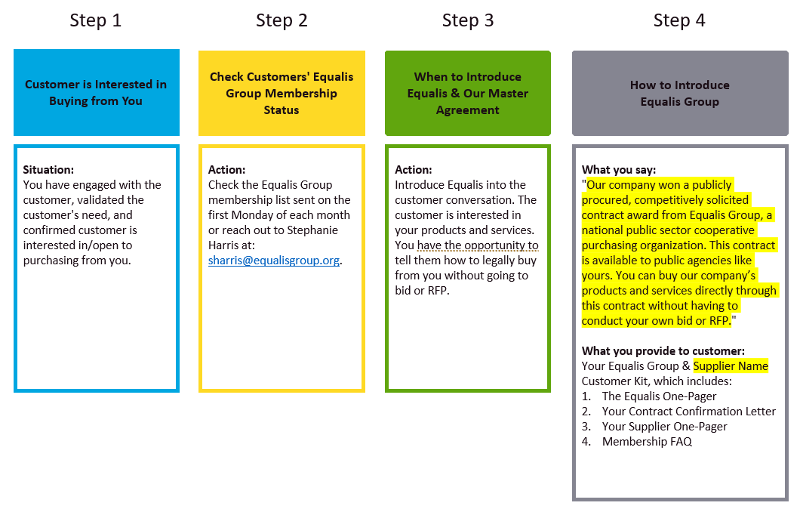

11. For Sales Reps: Questions Asked Frequently by Reps
Purpose & Description: to provide easy and concise answers to three questions sales reps often ask us in their interactions with customers during the sales process.

The questions are shown in the text boxes on the left side of the graphic below. The right text boxes include: 1) what steps the sales reps should take, and 2) what the sales rep should say to a customer “highlighted in yellow”.

Context: sales reps are typically moving fast when it comes to trying to close deals. Our goal below is to provide sales reps with simple answers to common questions so they can continue moving quickly. Of course, our sales team is available to engage with customers and answer these questions, or any other questions that arise relating to Equalis, our Master Agreement, compliance, procurement, and legal matters.

Link: Member Registration/Join Page

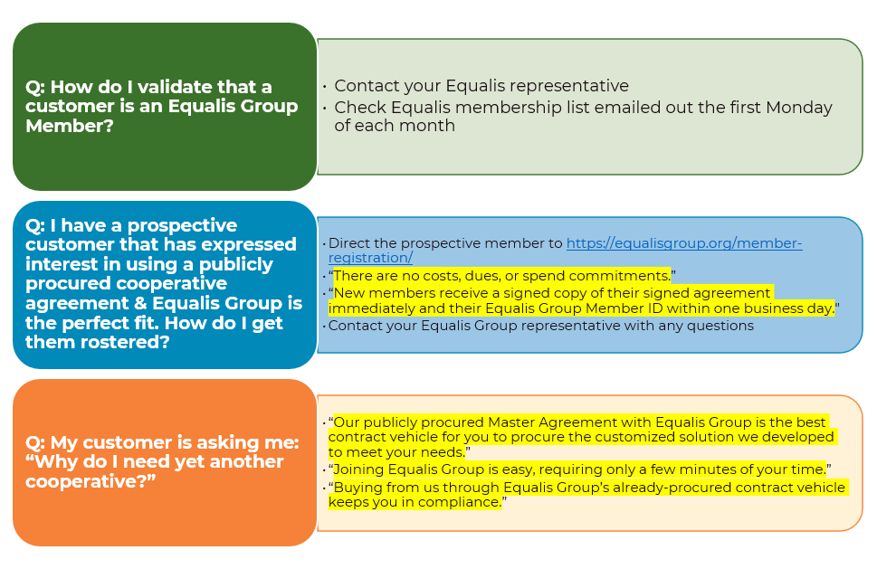

12. For Sales Reps: Questions Asked Frequently by Customers
Purpose & Description: to provide easy and concise answers to questions customers often ask sales reps during the course of the sales process.

The questions are shown in the colored text boxes at the top of the graphic below. The second row of the first two common questions provides additional information for the sales reps. The bottom text box includes how the sales rep should respond to the customer question “highlighted in yellow”.

Context: sales reps often ask us how they should respond to these common customer questions.

Our first response is that our sales team is here to answer these questions, or any other customer questions that arise relating to Equalis, our Master Agreement, compliance, procurement, and legal matters.

We recognize, however, that sales reps are typically moving fast when it comes to trying to close deals and they do not necessarily believe they have the time to engage our sales team with the customer. Our goal below is to empower sales reps with quick and impactful answers to common questions so they can continue moving quickly through the sales process.

Links: Member Registration/Join Page
Contracts landing page
Federal Funds Resource Page

